AWS Task 4

Launch an EC2 instance (Linux and Windows) along with a web server. Then, create an EBS volume of 5 GB, attach it to an EC2 machine (Linux and Windows), and take a snapshot. Finally, create an EBS volume using the taken snapshot.

🡪Launch Linux EC2 Instance with Web Server

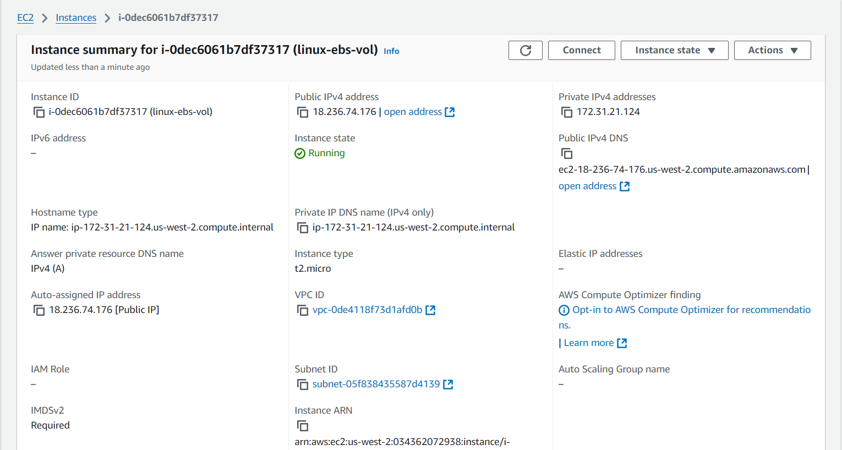

🡪Create Web Sever in Linux EC2 machine

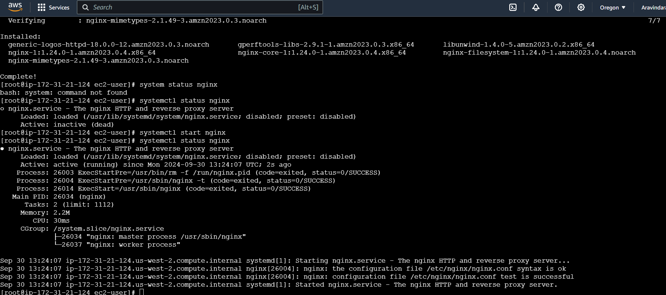

🡪Create EBS Volume for Linux web server

Volume 🡪 Create Volume 🡪 Select GB 🡪 Create Volume

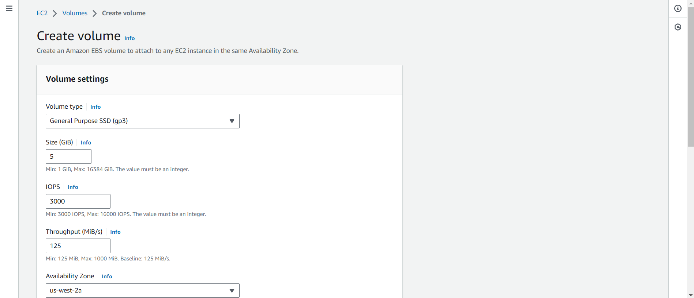

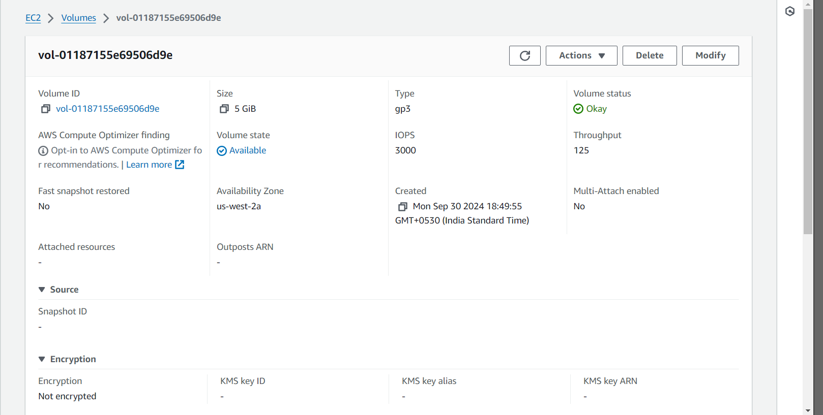

🡪No volume attached to Linux Machine

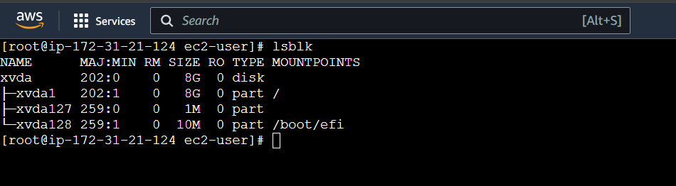

🡪Attach volume to the Linux EC2 instance

Action 🡪 Attach Volume 🡪 Select EC2 instance 🡪 Select device name 🡪 attach volume

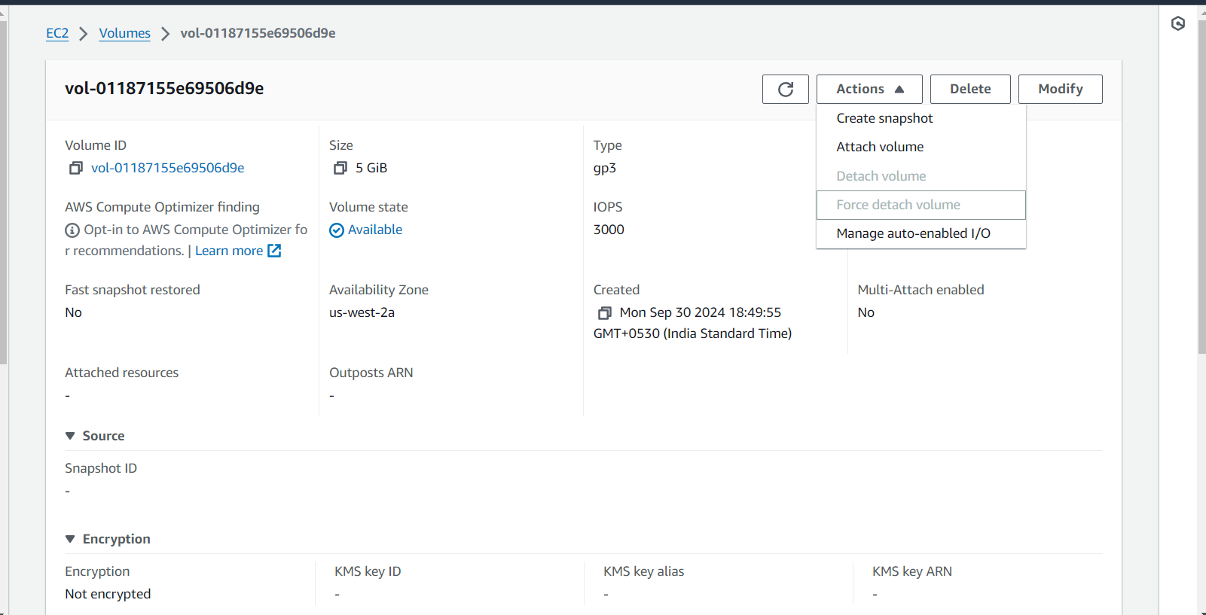

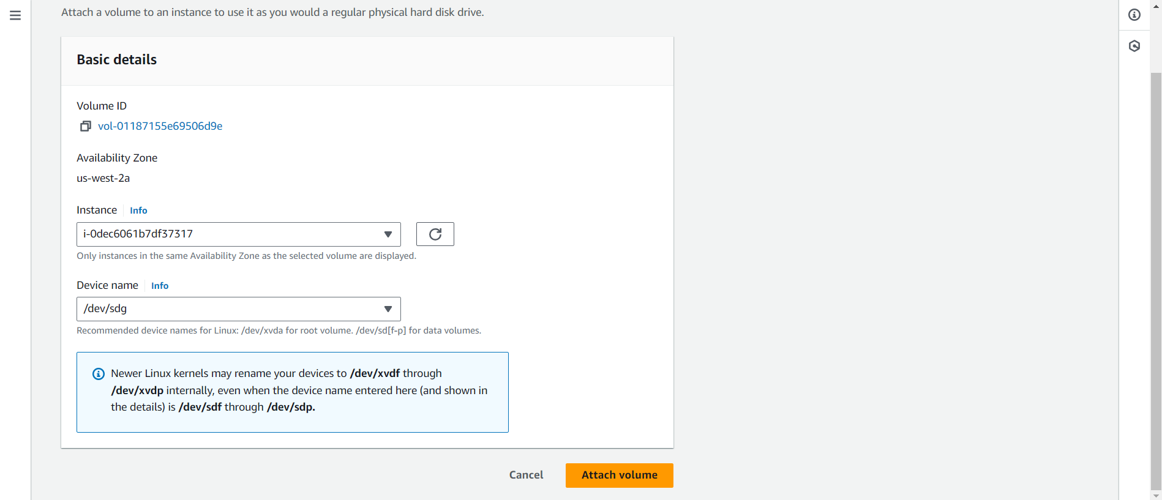

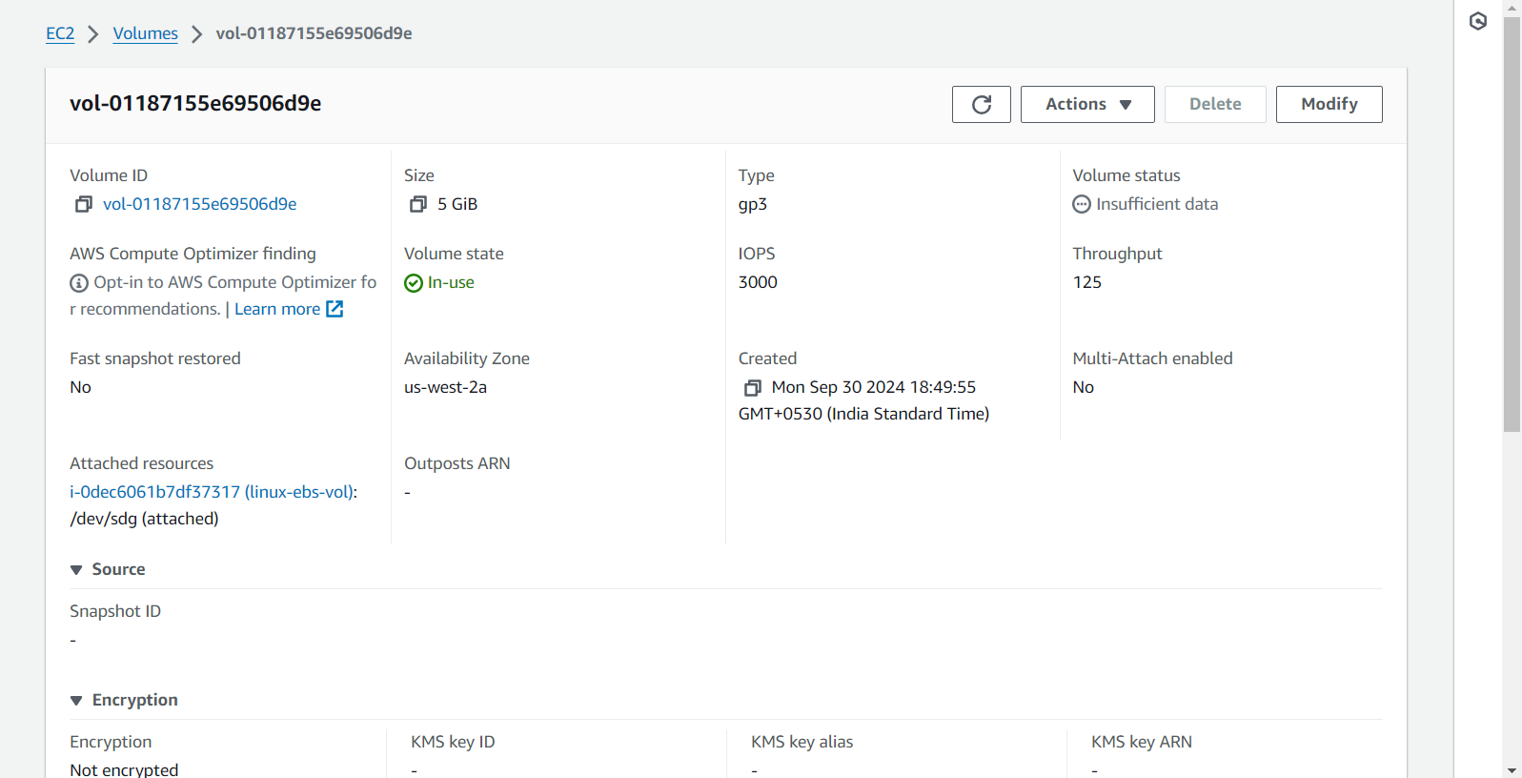

🡪Check volume and storage in Linux

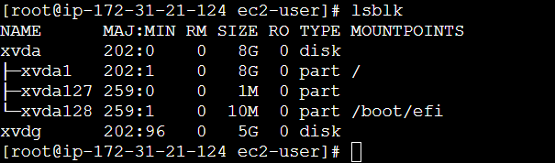

🡪Check disk partition

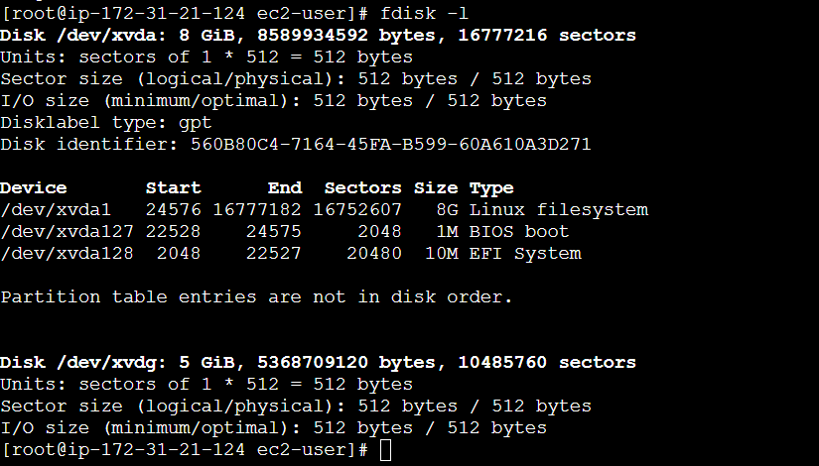

🡪Creating Snapshot from Linux EBS Volume

Action 🡪 Create Snapshot 🡪 Enter description 🡪 Create Snapshot

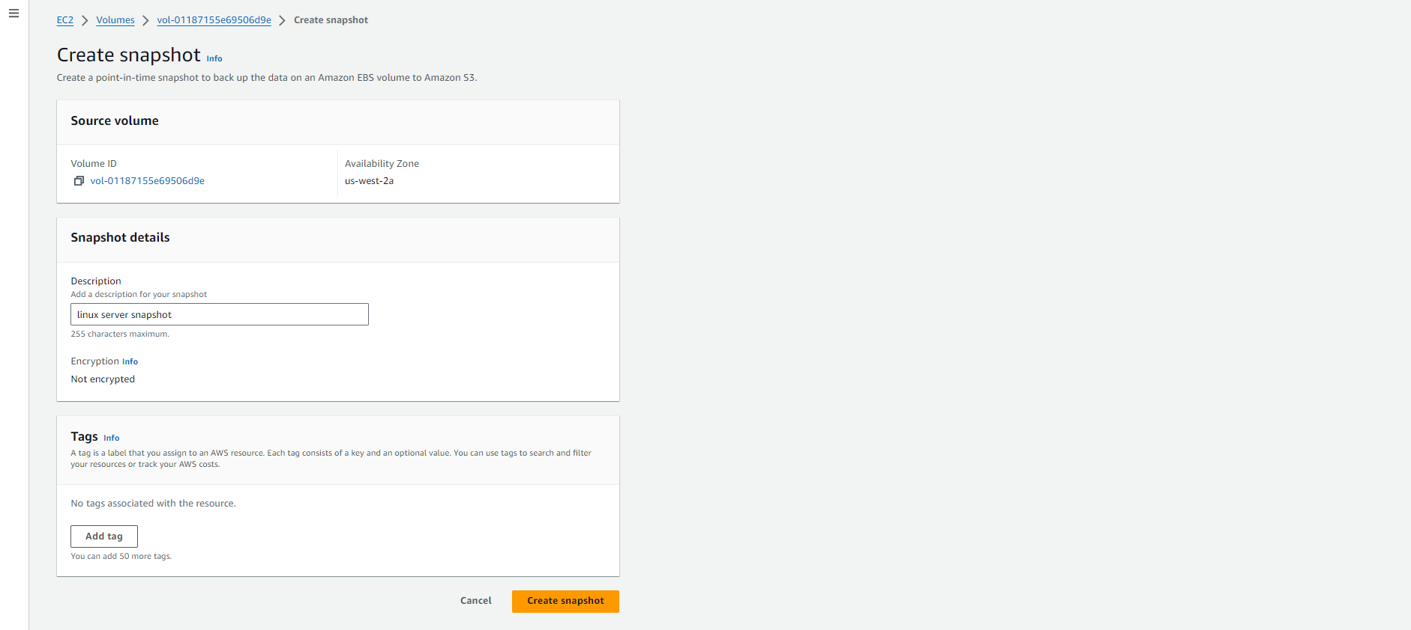

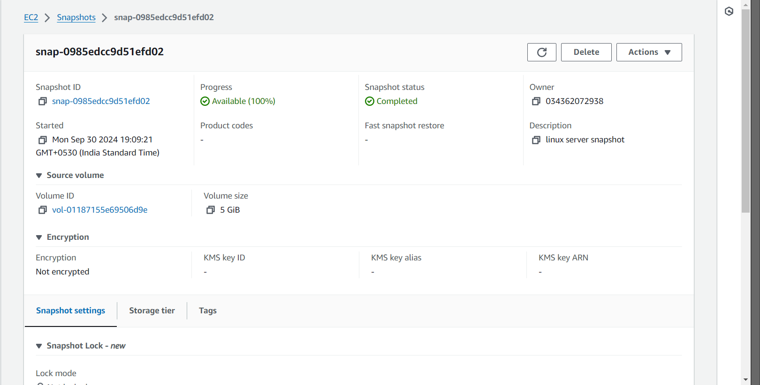

🡪Create Volume from Snapshot

Action 🡪 create volume from snapshot 🡪 Create Volume

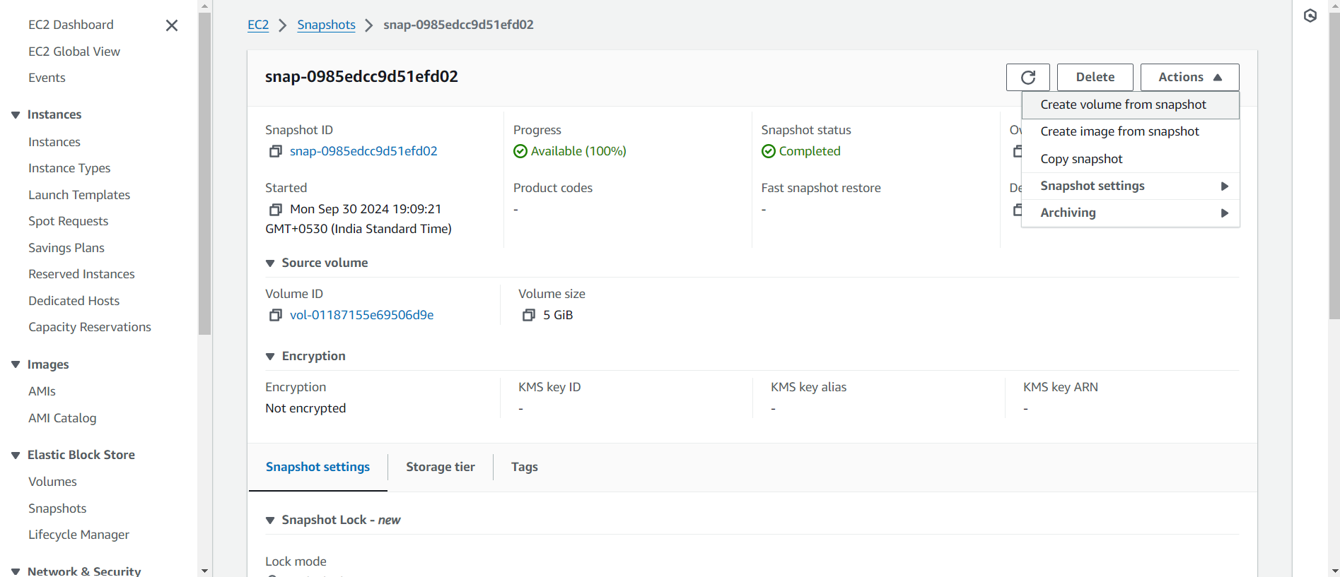

🡪Volume created from the snapshot from volume attached to linux server

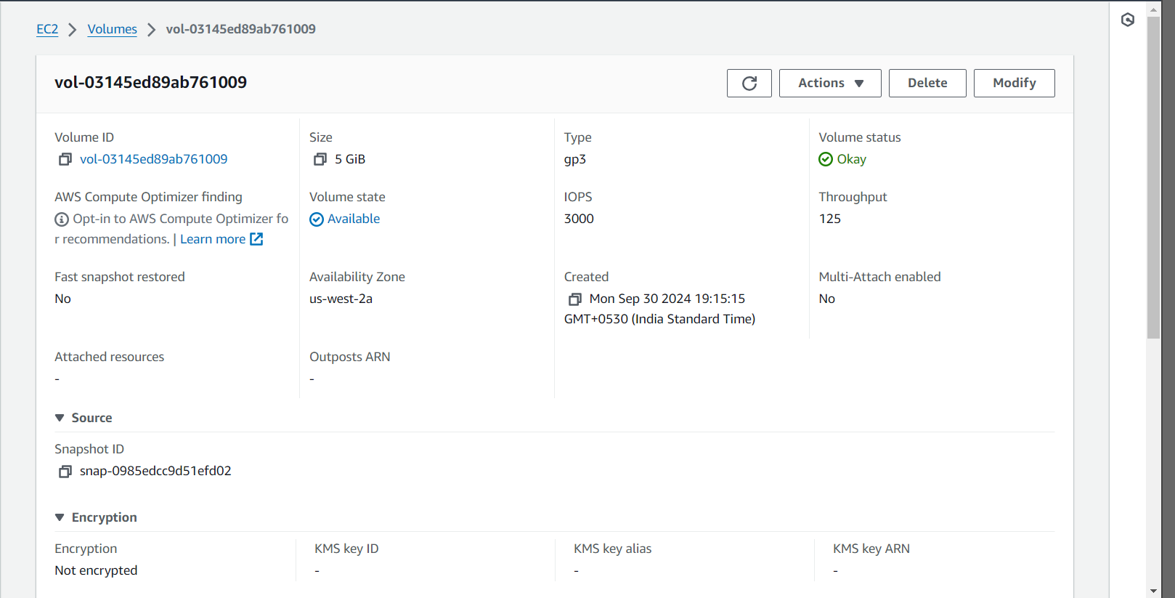

🡪Launch Windows EC2 Instance with Web server

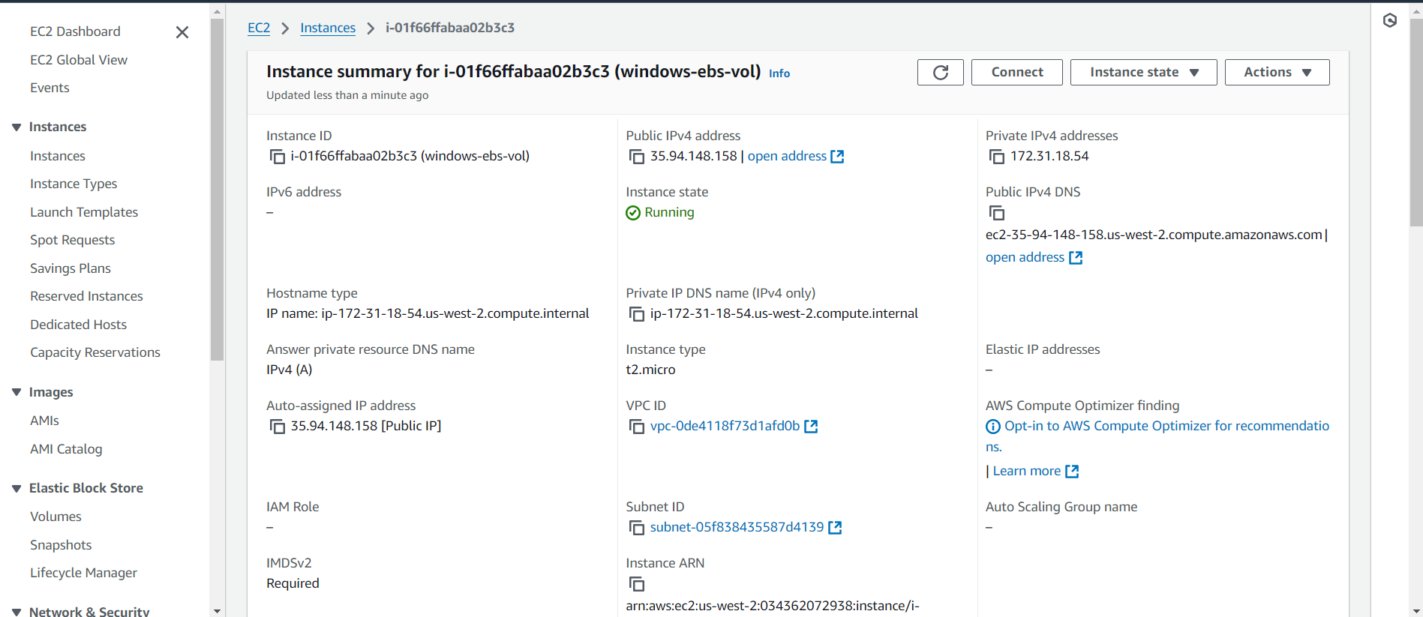

🡪Enable Windows IIS Server

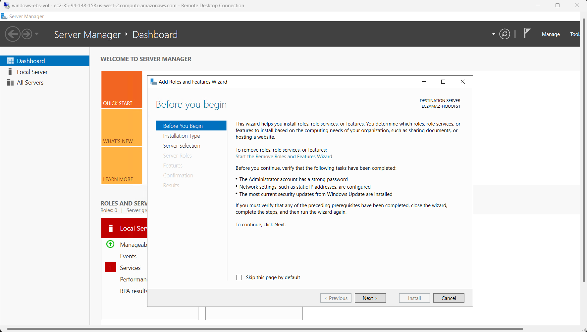

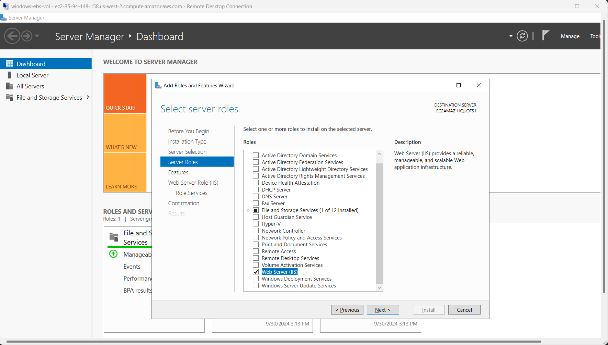

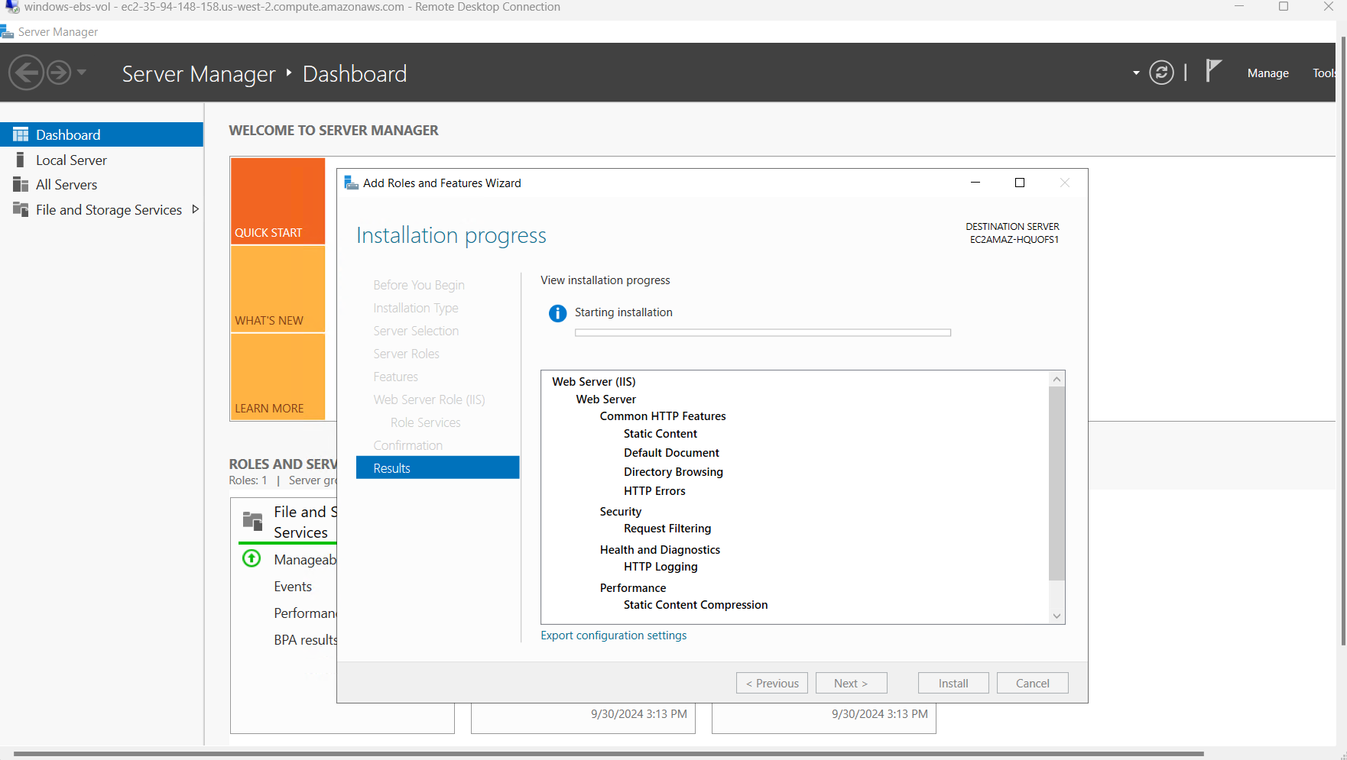

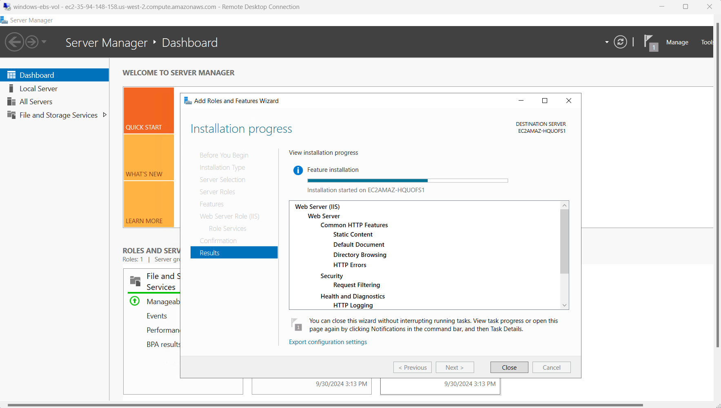

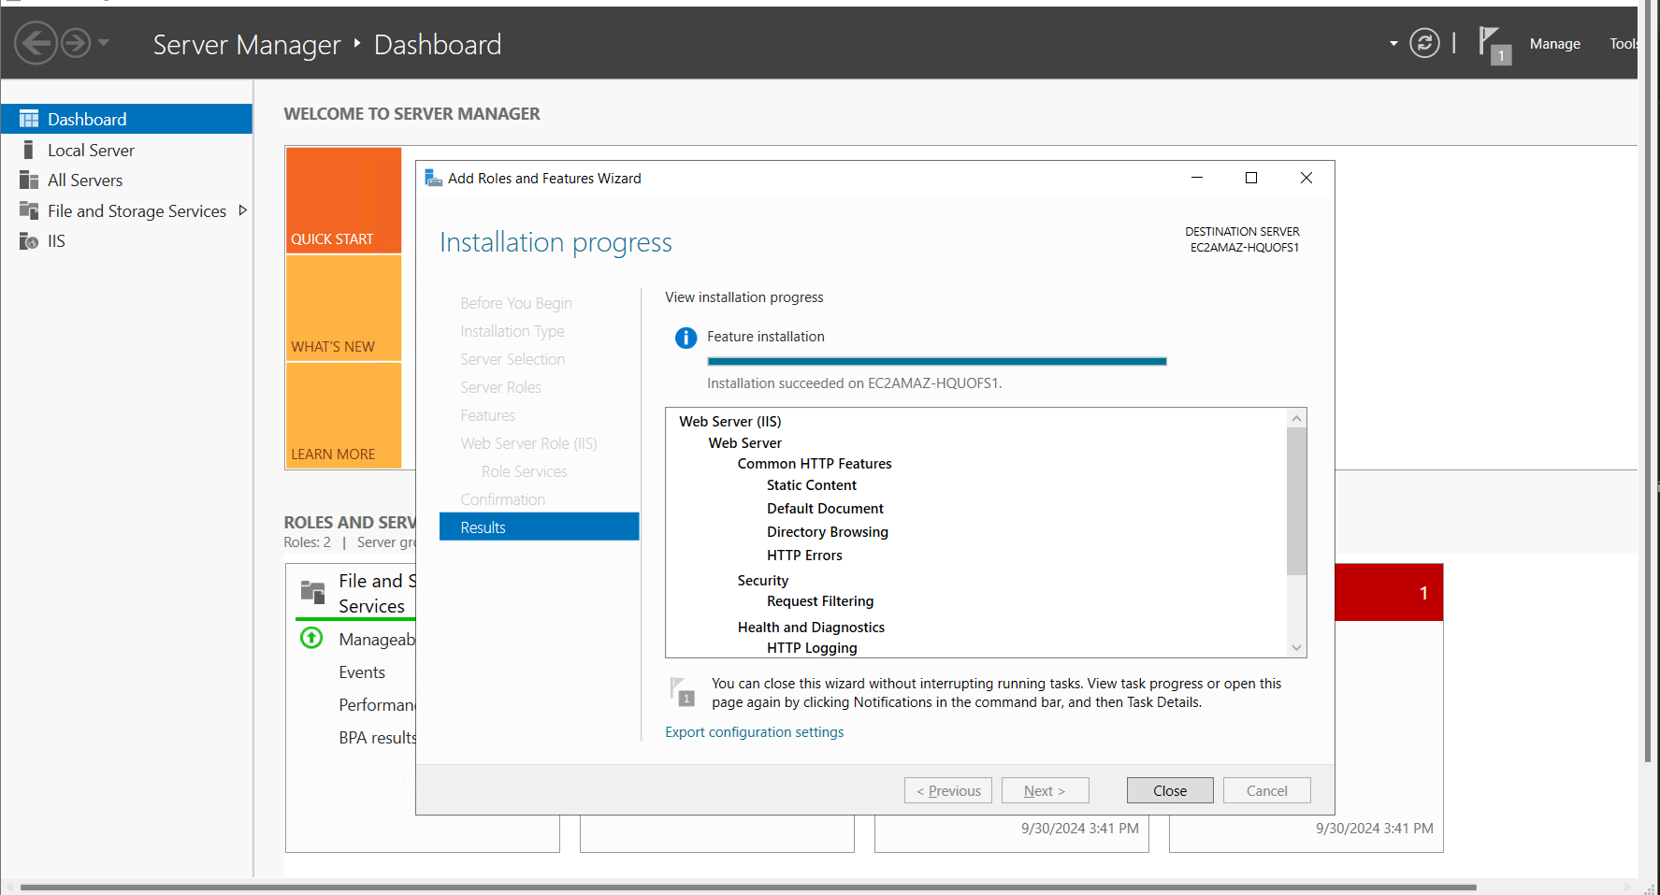

🡪Create EBS Volume for Windows web server

Volume 🡪 Create Volume 🡪 Select GB 🡪 Create Volume

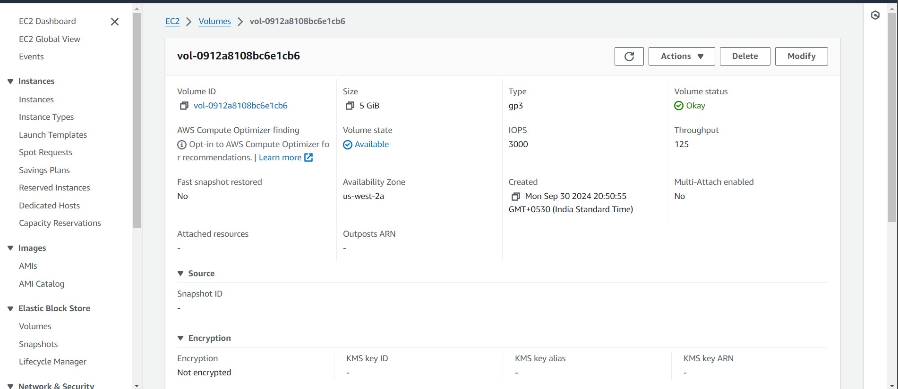

🡪Disk Management in Windows

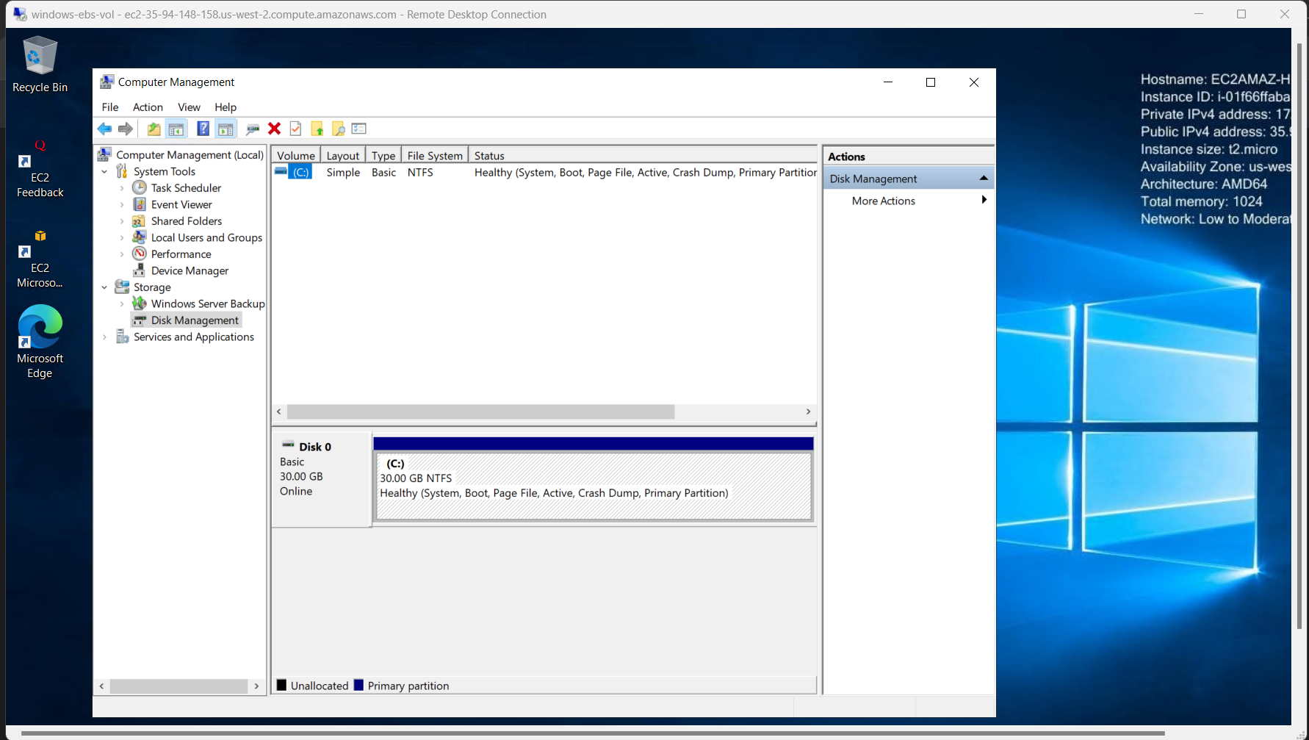

🡪Attach volume to the Windows EC2 instance

Action 🡪 Attach Volume 🡪 Select EC2 instance 🡪 Select device name 🡪 attach volume

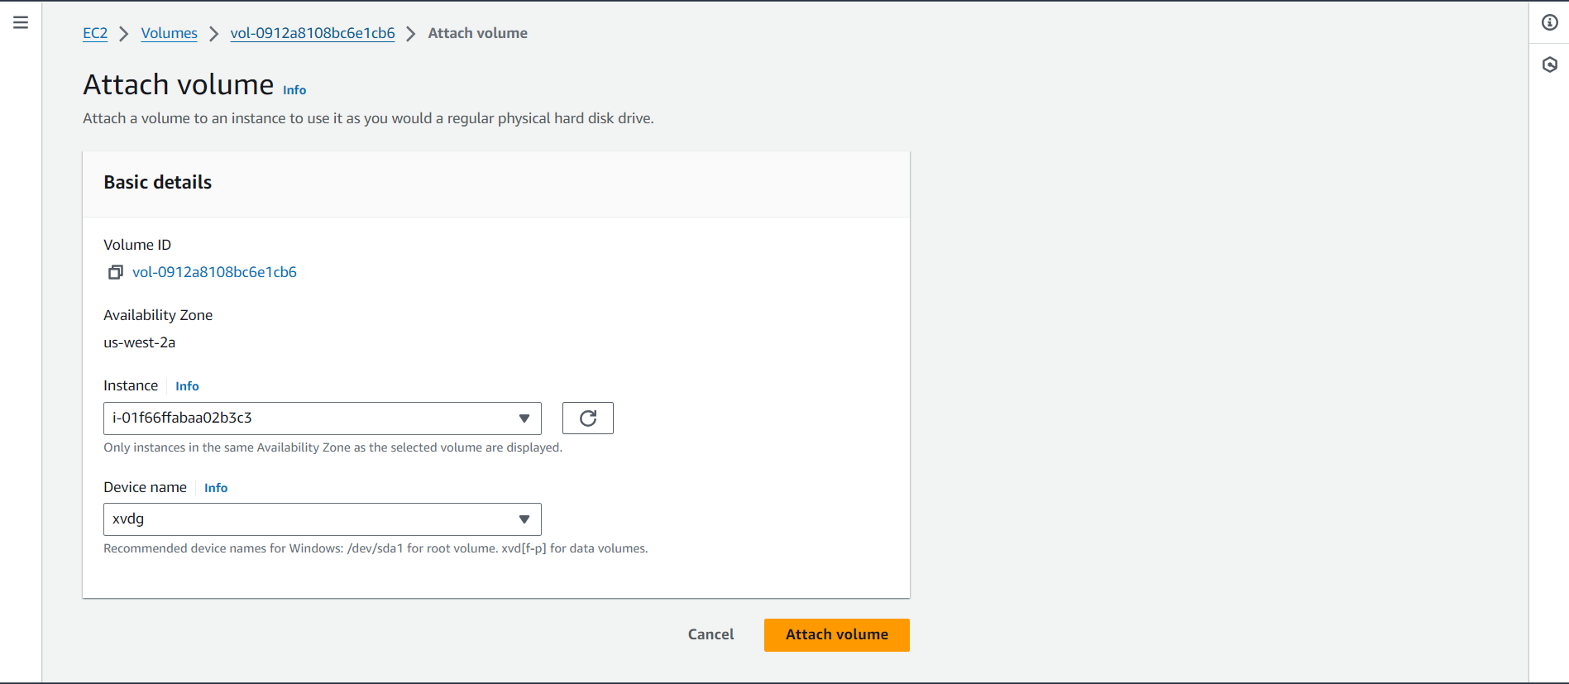

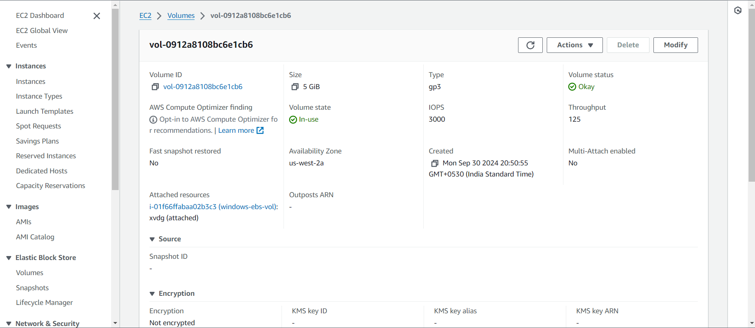

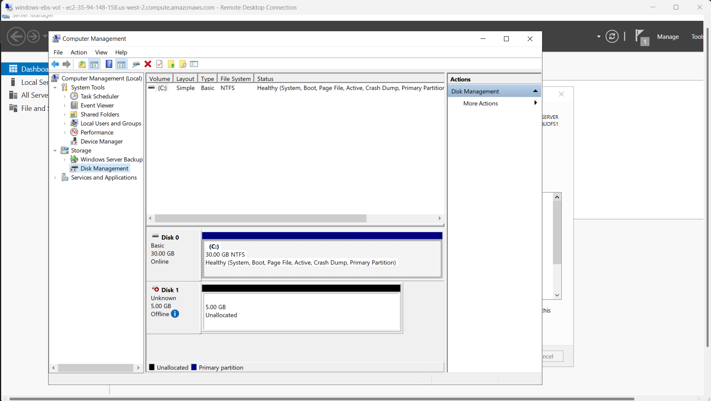

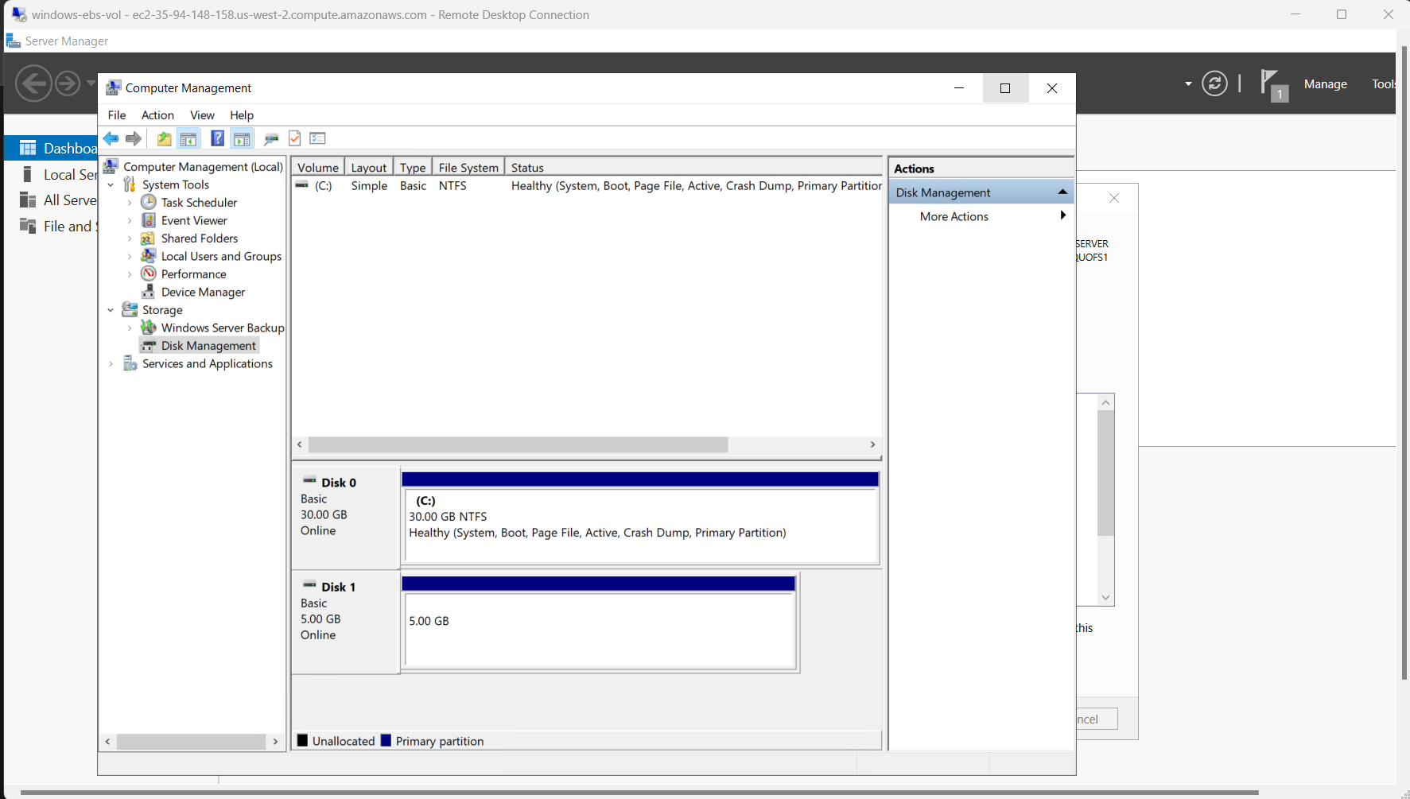

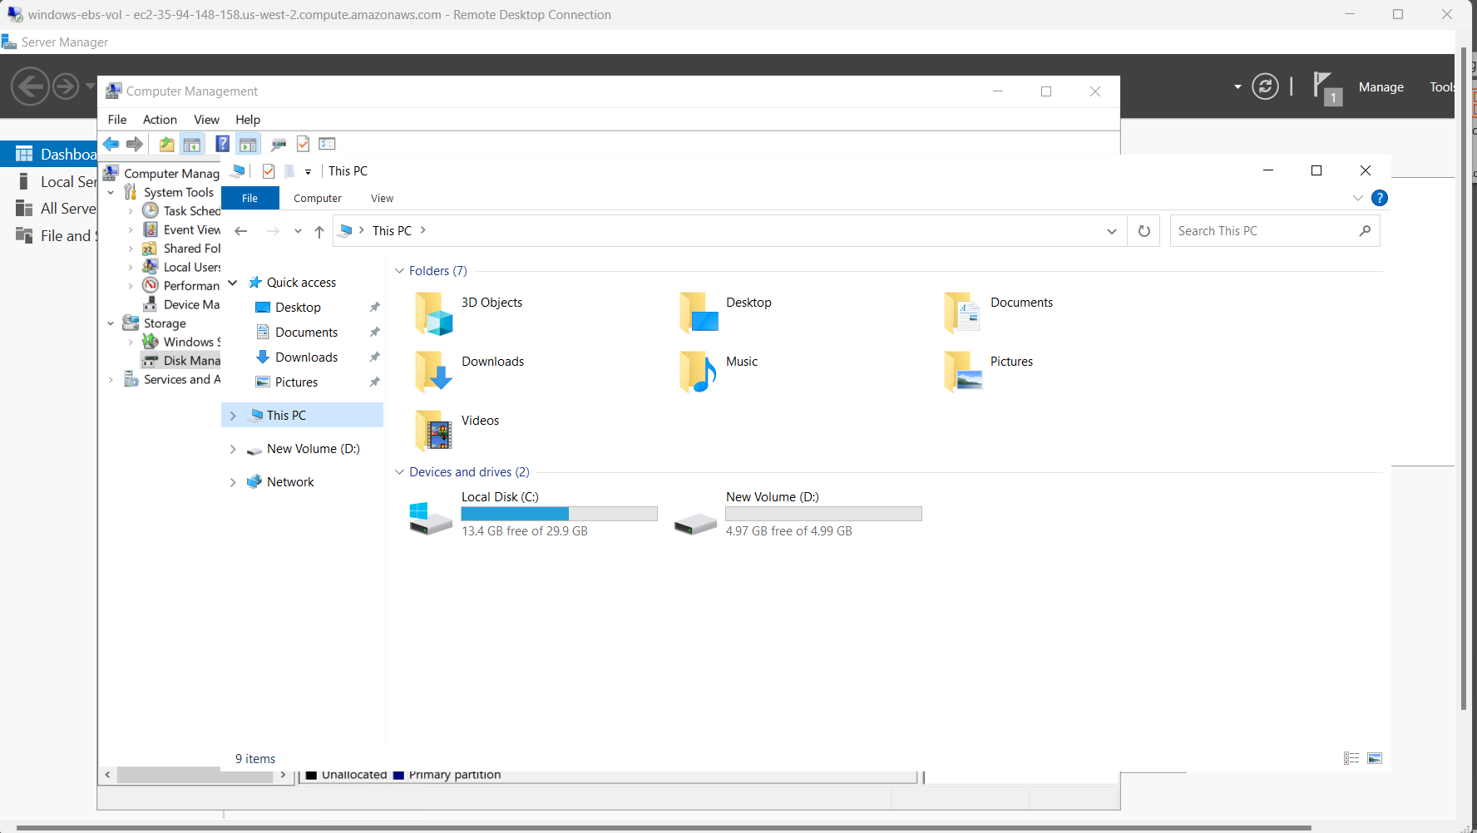

🡪Creating Snapshot from Linux EBS Volume

Action 🡪 Create Snapshot 🡪 Enter description 🡪 Create Snapshot

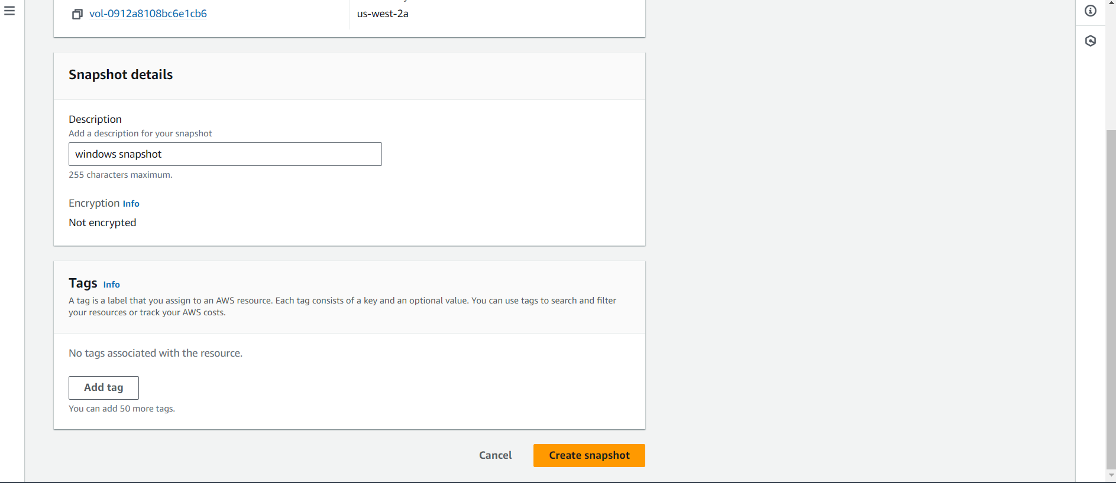

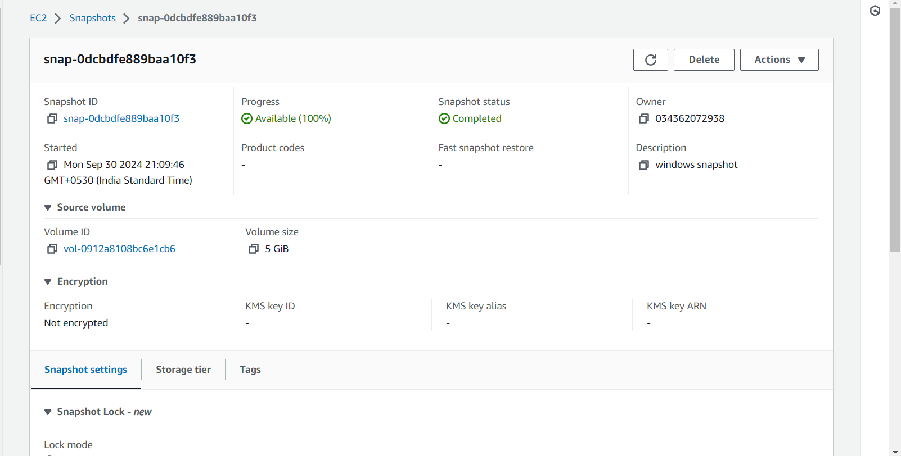

🡪Create Volume from Snapshot

Action 🡪 create volume from snapshot 🡪 Create Volume

